Cosmic Pi Version 1.5 PCB Assembly Guide J. Devine 20/11/17

Validity: This guide is valid for Cosmic Pi Hardware Revision 1.5, consisting of Version 2.5 Analogue and Main PCBs.

Part 1: Analogue PCB Version 2.5
The analogue PCB is designed for 2 usage modes:
1) Surface mounted Silicon Photo-Multiplier (SiPM) either on top, bottom or mixed top/bottom configuration. The footprint is designed for an Advansid 3x3 NUV SiPM, MPN: ASD-NUV3S-P
2) Surface mounted u.FL connectors (male) for connection to off-board SiPMs.

The majority of components are surface mounted on the top of the PCB. An LED and resistor can be mounted on the bottom of PCB if desired to allow light injection into a bottom mounted slab. These LED pads are wired in parallel with the LED pads on the top of the PCB.

The PCB has 3 through hole components: 2 sets of 4 2.54mm male pins and 1 set of 2 2.54mm male pins. These are to be mounted on the bottom of the PCB with solder joints on the top of the PCB. These pins act as a header to allow connection to the Main PCB.
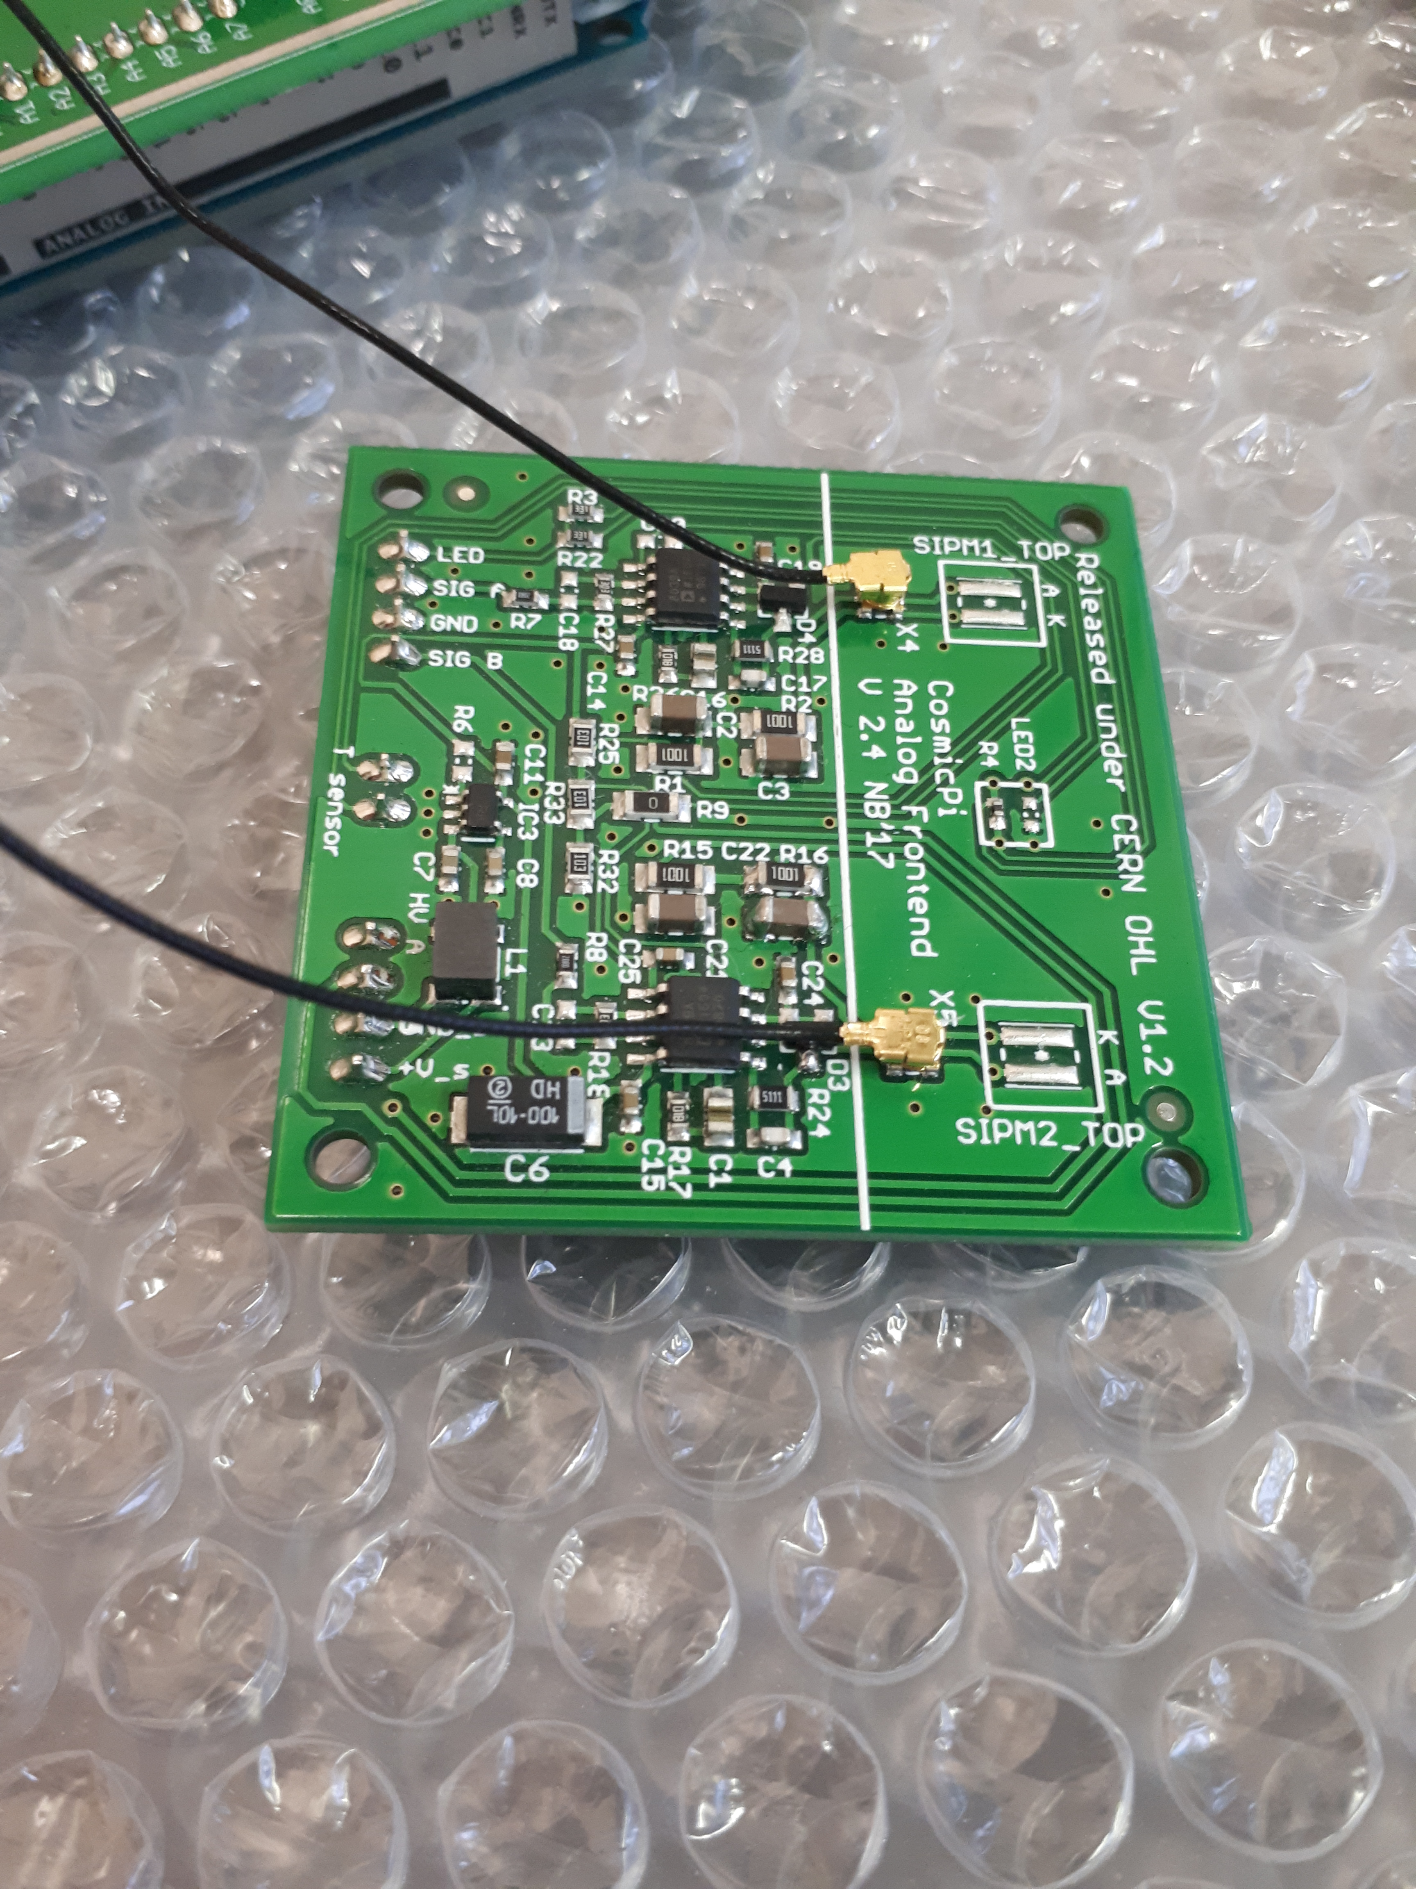
Figure 1: Top side of the Analogue PCB with u.FL connectors fitted and connected.
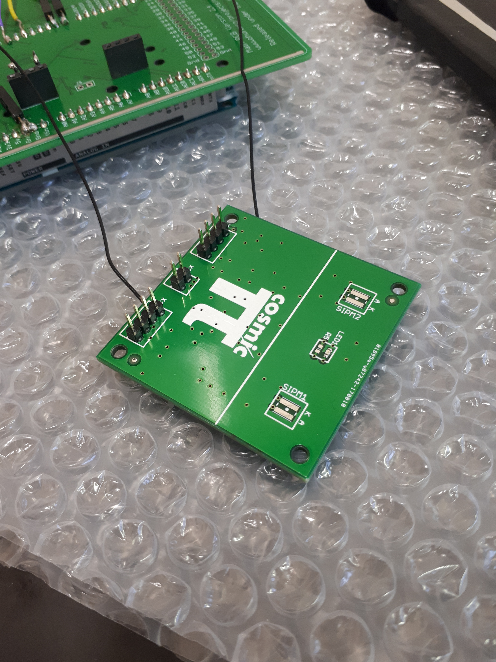
Figure 2: Bottom side of the Analogue PCB 3 sets of pins shown, with optional light injection LED shown mounted.
Part 2: Main Board Version 2.5
The main board of the Cosmic Pi contains all the components required to interface the Analogue PCB with an Arduino DUE.

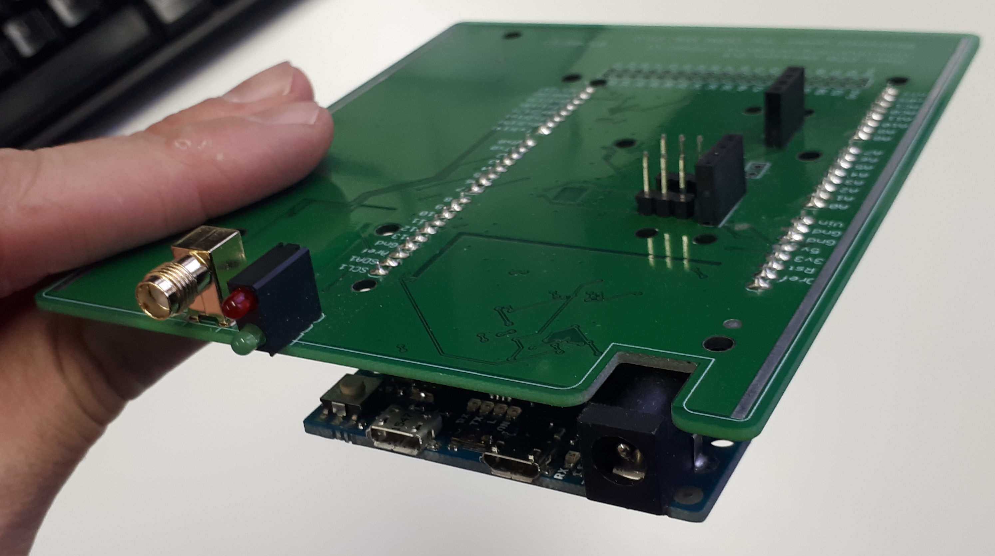
Figure 3: Top side of Main PCB shown with Arduino Due attached underneath. Note that the 2 sets of 3 male 2.54mm pins adjacent to the analogue board header have been removed from the production version of this board.

All the surface mount components of the Main PCB are mounted on the bottom of the PCB, with only 4 through hole components mounted on the top.

The components to be mounted on the top of the Main PCB are as follows:
90 degree SMA connector (for GPS)
2 LED pillar module from Kingbright
2 sets of 4 female 2.54mm pitch sockets for mounting the Analogue PCB.
Note: the 2 male 2.54mm pins in the middle of the Analogue PCB are not connected in the production version, these pins are for future use with the next version of the design.

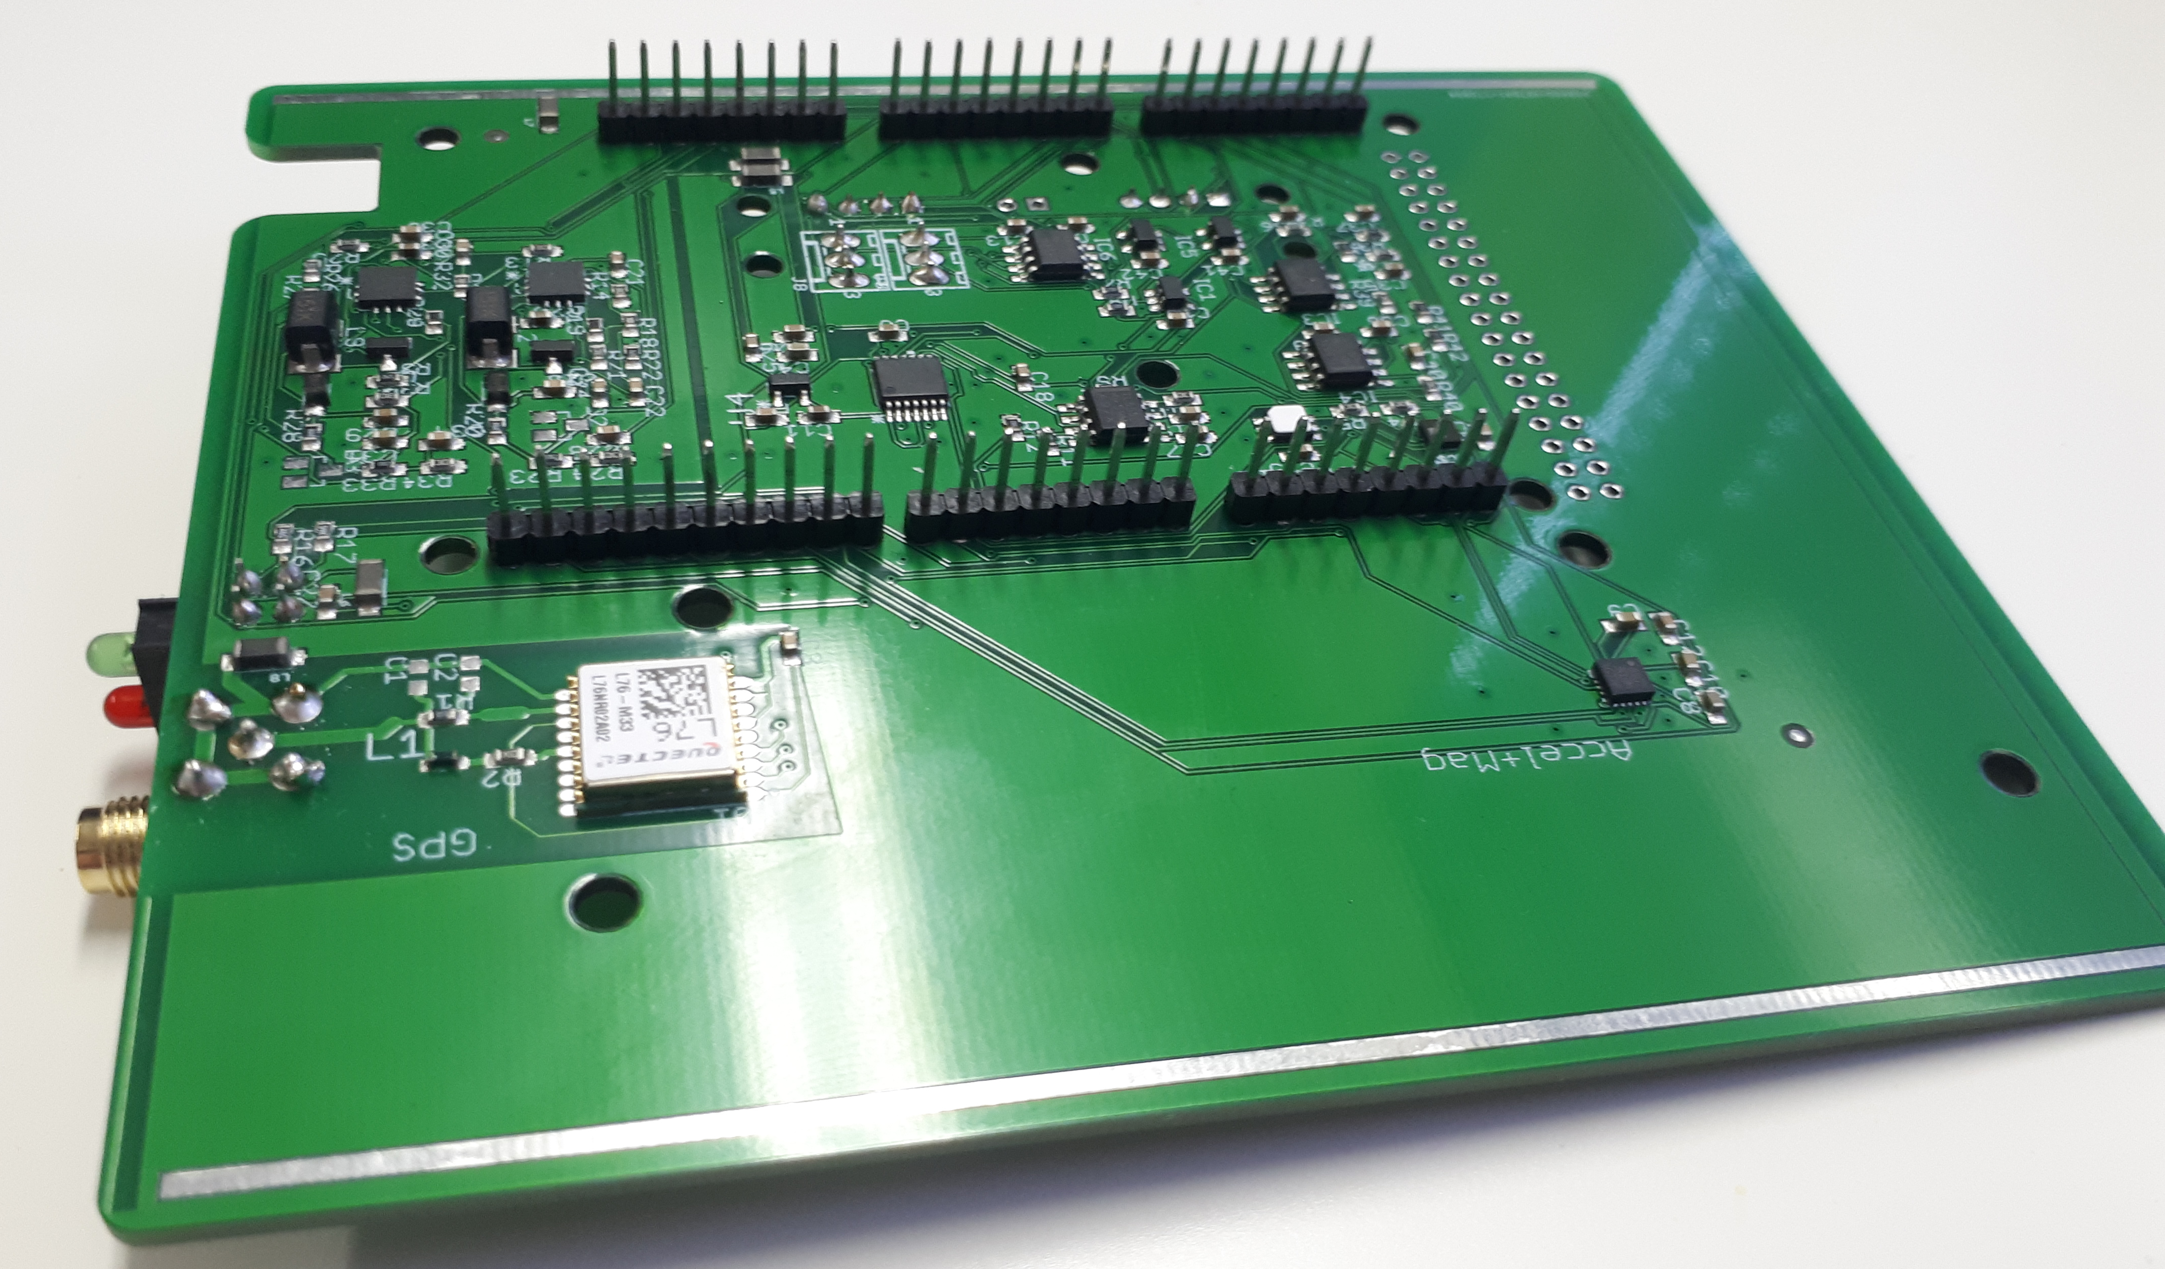
Figure 4: Bottom of Main PCB.
The following through hole components are to be mounted on the bottom of the PCB:
5 No. 8 pin 2.54mm pitch male pins
1 No. 10 pin 2.54mm pitch male pins
Note that the 40 pin header at the end of the PCB for Arduino DUE connection is not populated in this version of the PCB. This is because the pins are not required and impede the removal of the Arduino.

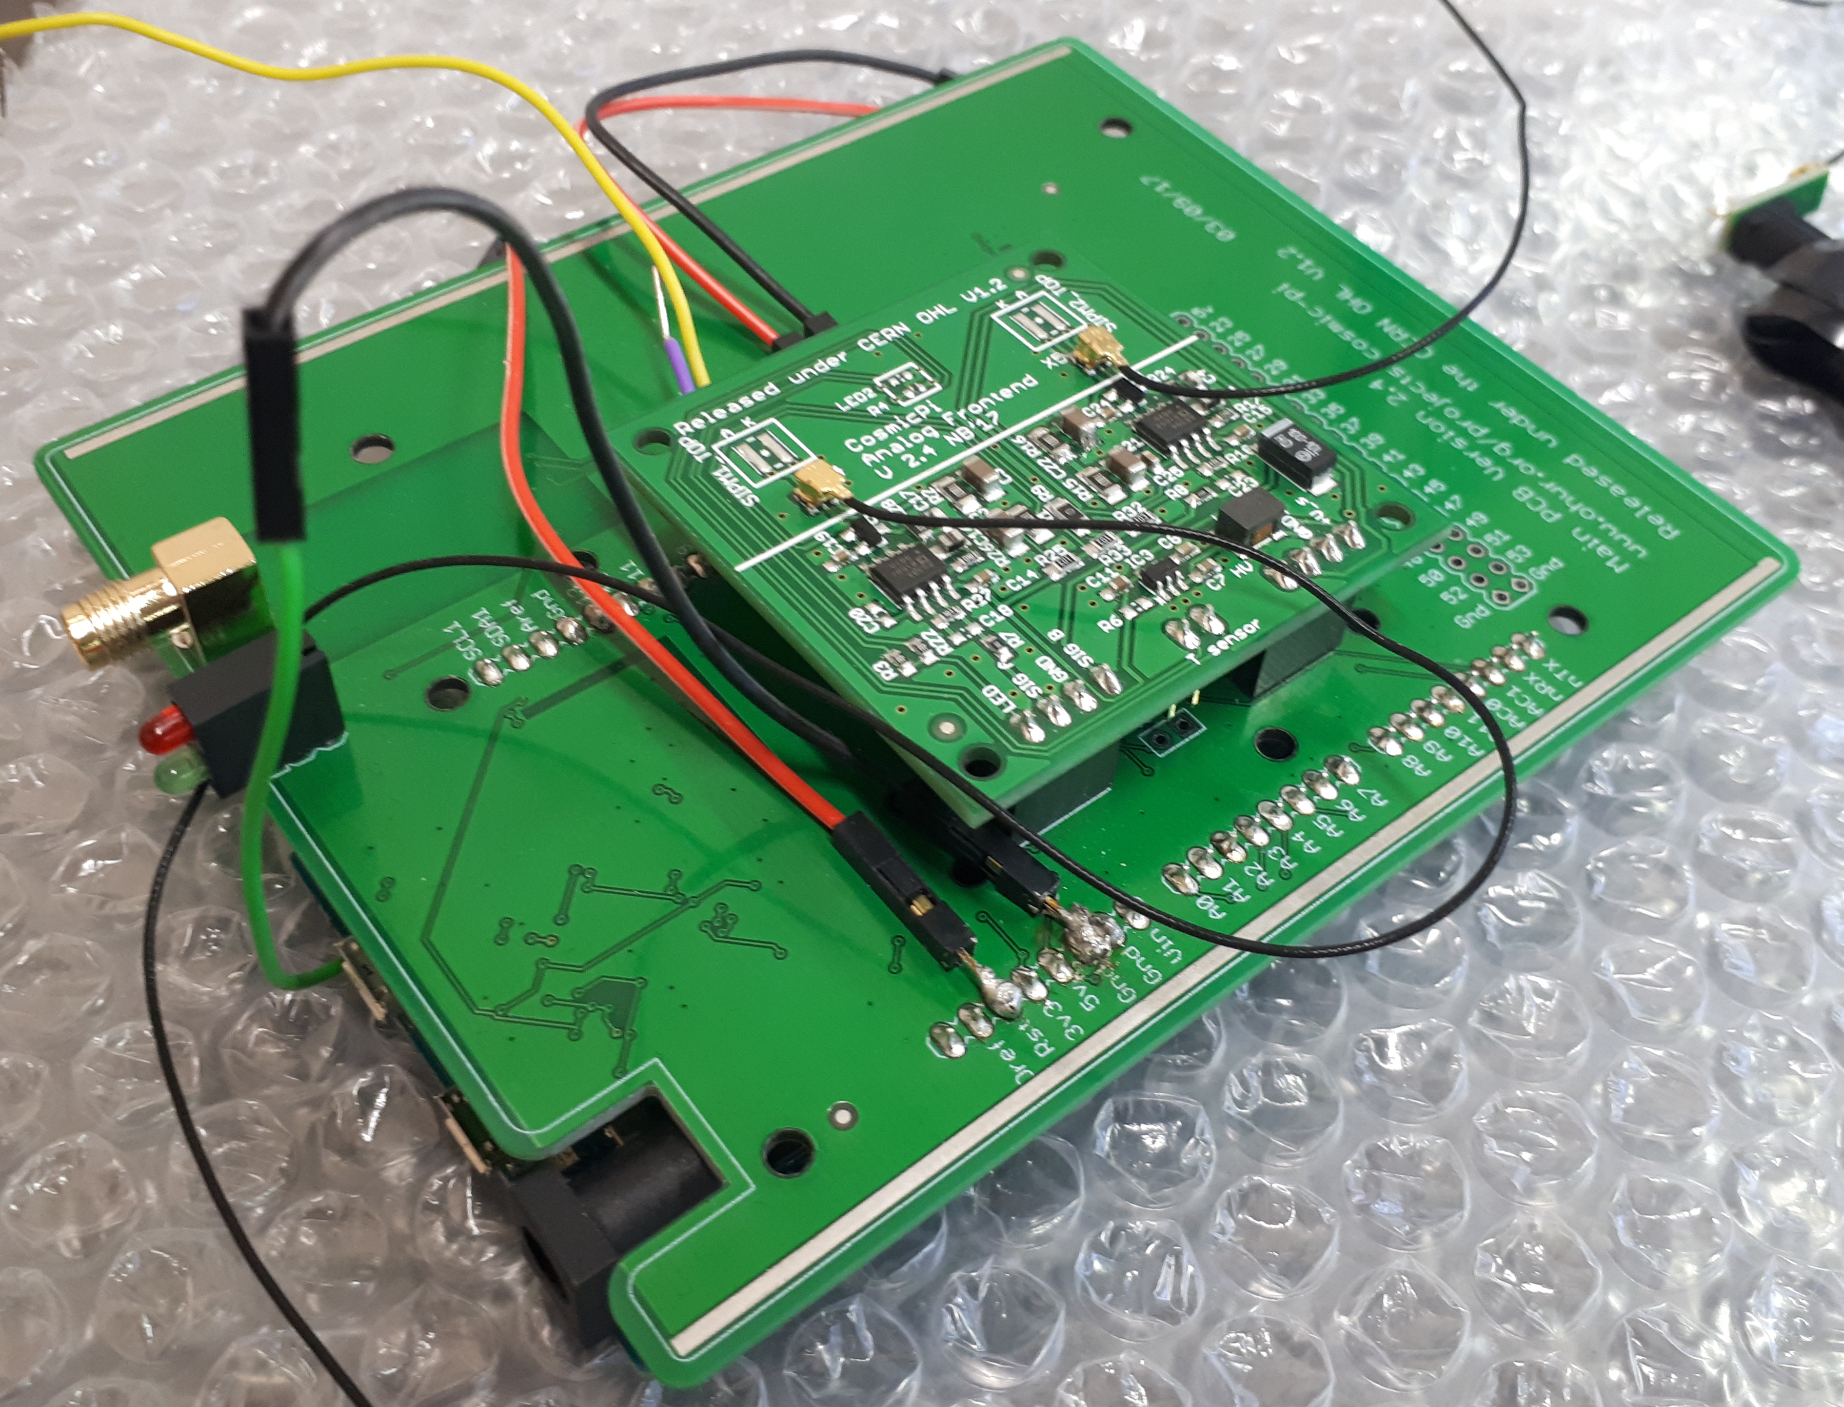
Figure 5: Fully assembled unit with Analogue PCB, Main PCB and Arduino DUE. Note that the extraneous wires are due to this unit being used for testing and do not form part of the design.

